DATE: 21.08.2025

EXPERIMENT – 15 Create a Cloning of a VM and Test it by loading the Previous Version/Cloned VM using vmware workstation

Aim:

To create a clone of a virtual machine and test it by loading the cloned VM using VMware Workstation.

Procedure:

1. Open VMware Workstation and select the virtual machine to be cloned.
2. Ensure the VM is powered off before cloning.
3. Go to VM → Manage → Clone.
4. The Clone Wizard will appear → Click Next.
5. Select Clone from an existing snapshot or current state.
6. Choose Full Clone (creates a complete independent copy) or Linked Clone (shares virtual disks with parent).
7. Provide a name and location for the cloned VM.
8. Click Finish → VMware will create the cloned VM.
9. Once created, power on the cloned VM from the VMware Workstation library.
10. Test the cloned VM to verify it loads properly and works independently of the original VM.

Output:

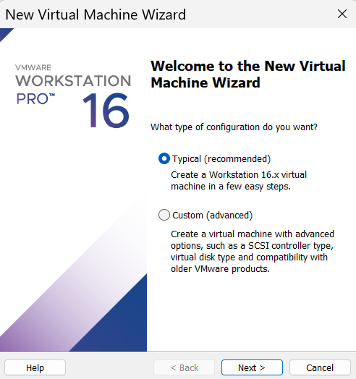

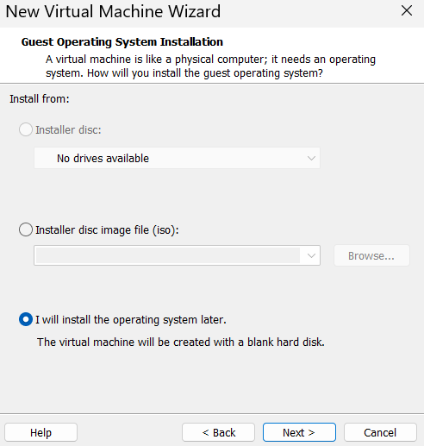

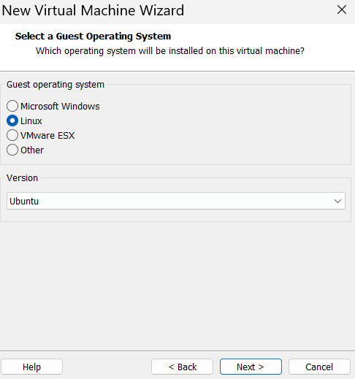

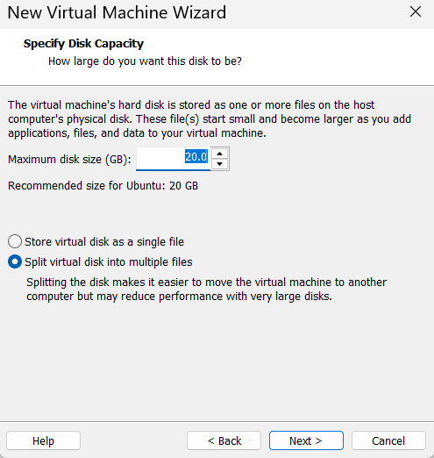

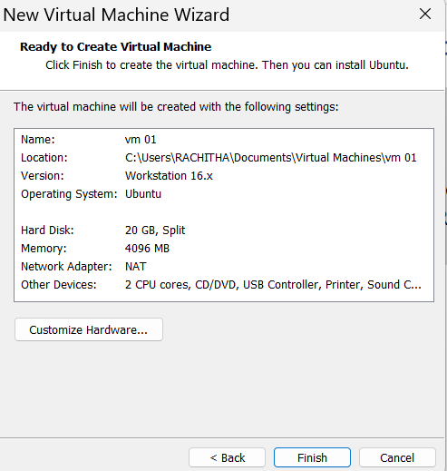

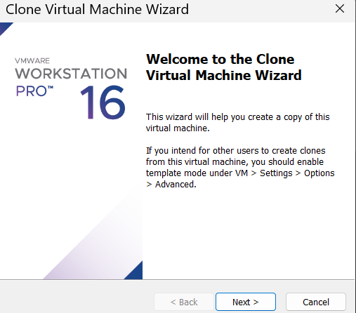

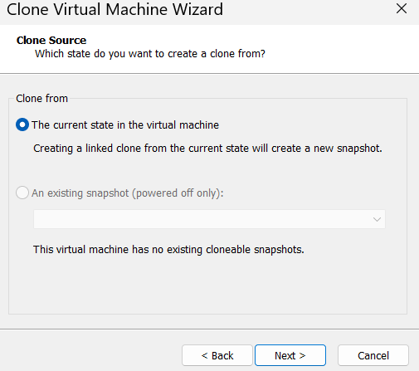

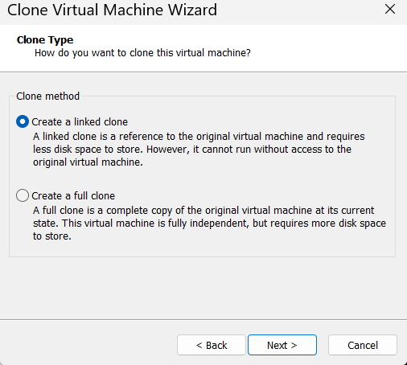

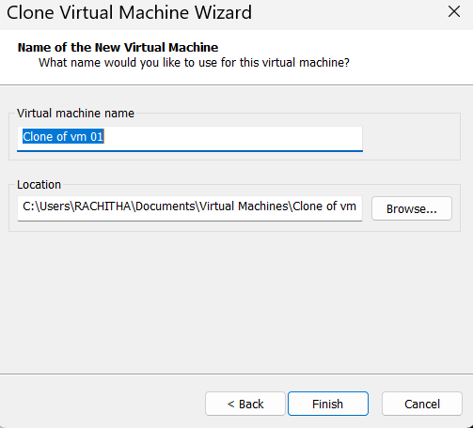

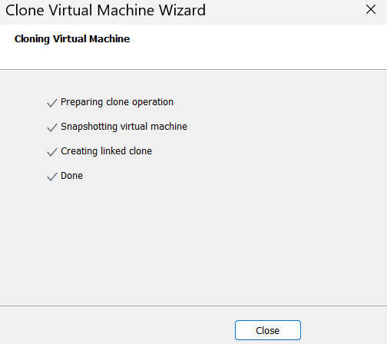

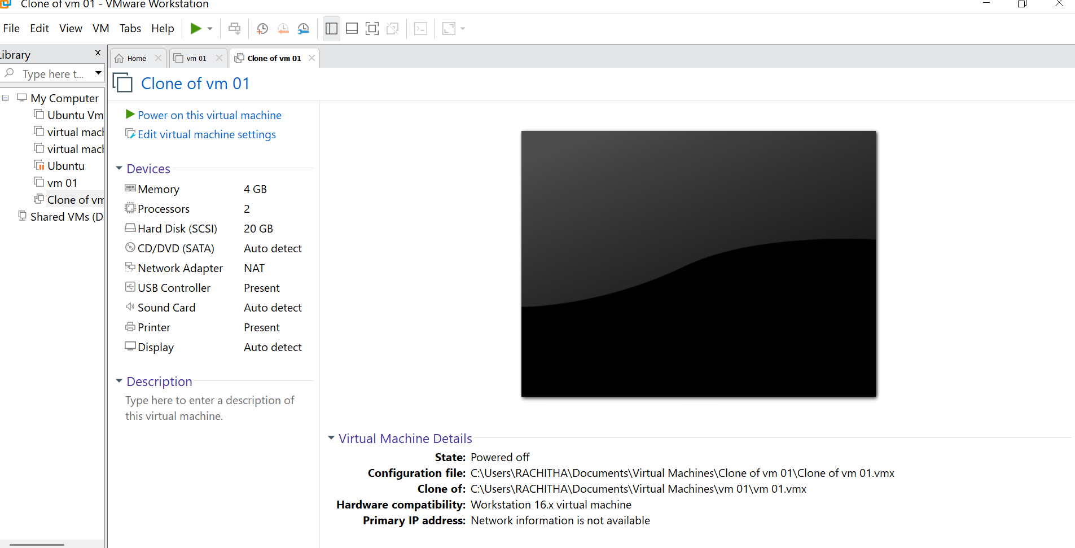

Result:

A clone of the VM was successfully created and tested. The cloned VM loaded correctly and functioned independently from the original VM, demonstrating the cloning feature of VMware Workstation.